Step for upload pdf files simultaneously with the CSV file

1. Select the csv File.
2. File format should be as bellow screen.

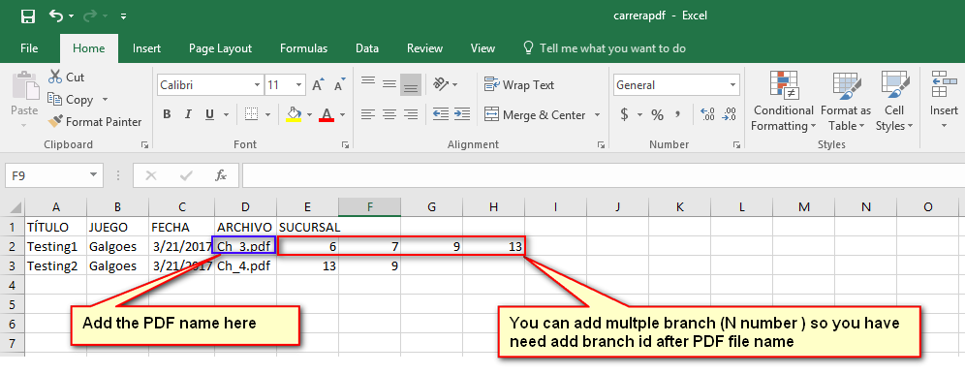

1. Select PDF files what we want to add simultaneously, we need to select all files at a time so please keep all pdf file in the any one folder and then select PDF files.

